**DENEISHA BLAKE**

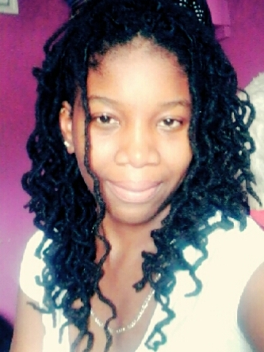

15 Lexus Boulevard,

Harmony Hall,

Marabella

(868) 319-3592

[neishab1@hotmail.com](mailto:neishab1@hotmail.com)

**CAREER OBJECTIVE**

To be employed in a position that suites my qualifications in your established business. My goal is to perform all tasks given to me to the best of my ability and in a timely manner. I hope to add a great value your business by show casing my abilities and by applying all that I have learnt. I also hope to enhance my abilities and grow as an individual whilst fulfilling my duties.

**EDUCATION**

* **The University of Trinidad and Tobago (UTT)**

National Engineering Technician Diploma Chemical Engineering - May 2014 - present

* **Marabella North Secondary (MNS)**

**CXC May/June 2013 GRADE**

English A I

Mathematics II

Chemistry II

Physics II

Technical Drawing II

Biology III

Geography III

**SKILLS**

* Laboratory Skills in Chemistry
* Laboratory Skills in Engineering Science
* Team work Skills
* Leadership Skills
* Communication Skills
* Organizational Skills
* Great Public Speaking Skills
* Proficient in the use of Microsoft Word

**PROJECTS**

* **Co-Op Project –Kiss Baking Company Limited (KBCL) 2016**

During the 3 month training at KBCL our objective was to collect as much process parameters and data as possible to set trends. This was done to improve the consistency of the products. I underwent this project for the dessert area of Kiss. Data was collected for the roots cakes which included, chocolate, butter sponge, orange sponge, marble, red velvet, eggless sponge and eggless chocolate. From the data collected I was also able to update employee data collection sheets so that more data can be collected when my training had come to an end.

* **Educational Diversity 2014** RBC’s Young Leaders project was undertaken at the Marabella North Secondary School. During which we tried to incorporate different styles and techniques used in Trinidad and Tobago by the various cultures and races among the people of this country. The diversity of our people and our cultures was the main idea of our project. Leadership and teamwork skills were developed during this project.
* **An Investigative Report on the Incomplete Recreational Play Park in Harmony Hall Marabella.** **2014**

This project investigated why the park was left at a standstill and the opinions of residents living in that area about the problem. Recommendations were also advised to suggest the positive role the park plays in the community and why it should be completed.

**HONORS AND AWARDS**

* Excellence in Geography upon graduating Marabella North Secondary 2014
* Award for Contribution in the Co-operate Life of Marabella North Secondary 2014
* Award for School Prefect of Marabella North Secondary 2014
* Head Young Leader for Marabella North Secondary 2013

**WORKING EXPERIENCE**

* RMSL Pharmacy

Union Road, Marabella.

6 months

Duties: Assist customers

Cash

Receive stock

Price goods

Restock goods in their respective places

Restock tablets in tablet bags

Package sweets to sell

Record invoices

Balance phone cards sales

Make copies for customers

Pack fridge with drinks

General house cleaning before shift ends

* Co-Op Training – Kiss Baking Company Limited

12-14 Lange Park, Chaguanas

3 months

Quality Control Inspector Trainee (Dessert Department)

Duties: Collect process parameters

Input data and set trends

Report non conformances

Create standard operational procedures (SOP’s)

Collect samples for each batch of batter monitored

Perform laboratory tests (pH, water moisture and specific gravity testing)

Review and improve employee data collection sheets

**REFERENCE**

* Mr. Aphtaap Mohammed

492-3844

Senior Instructor

University of Trinidad and Tobago

* Mr. Clyde Forde

718-1039

Technical Drawing Teacher/Disciplinary Deen

Marabella North Secondary